Tonight's Mission: Sonny AI COO
This is where Firmic becomes something genuinely different.
The roadmap I'd follow is:

Phase B.1 — Sonny Core Brain
- Persistent Memory
- Decision Engine
- Context Engine
- Company State
- Long-term Memory

Phase B.2 — Sonny Operations
- Task creation
- Task delegation
- Workflow execution
- Priority engine
- Deadlines
- Automatic follow-ups

Phase B.3 — Sonny Voice
- Voice conversations
- Speech-to-text
- Text-to-speech
- Voice commands
- Hands-free company management

Phase B.4 — Autonomous Company
- Sonny supervises Hermes
- Sonny supervises AI Workforce
- Sonny supervises Billing
- Sonny supervises Compliance
- Sonny supervises Support
- Sonny supervises Meeting Center
At that point, Sonny won't just answer questions—it will run the company.

And after Sonny…
That's when we begin what I think is the most exciting part:
A CEO opens Firmic in the morning and Sonny says:
"Good morning. Two invoices were paid overnight. One company is missing a Trade License. Receptionist AI answered 43 calls. Three support tickets require approval. A meeting room conflict has been resolved automatically. Revenue increased 6.2% this week. I recommend upgrading two tenants to Premium."
That's the experience we've been building toward.

So yes—let's call Phase A officially complete. Take a break, get something to eat, and recharge.
When you're back tonight, we'll start Sonny properly. I have a feeling that's going to be the most enjoyable phase of the entire project. 🚀
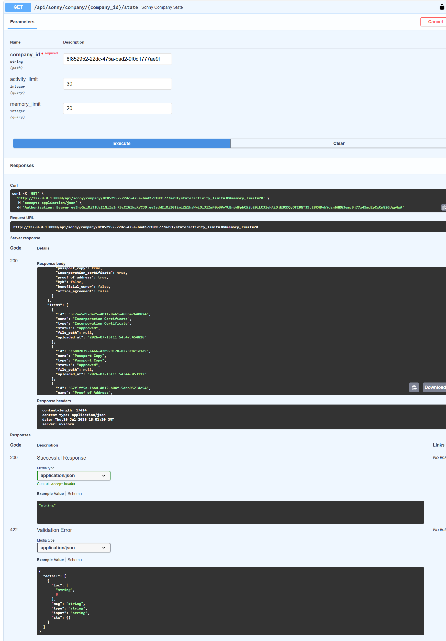

The roadmap I'd follow from here
B.1 — Sonny Core Brain
- ✅ Company State Engine
- ⏭ Decision Engine
- ⏭ Memory Engine
- ⏭ Priority Engine
- ⏭ Company Health Score
B.2 — AI Execution
- Workflow Executor
- Task Delegation
- Cross-agent messaging
- Audit logging
- Autonomous scheduling
B.3 — AI Workforce
- Julia
- Hermes
- Receptionist AI
- Finance AI
- Mailroom AI
- Meeting Coordinator
B.4 — Operating System
- Event Bus
- Automation Engine
- Background jobs
- Voice
- Real-time monitoring
- Executive dashboard

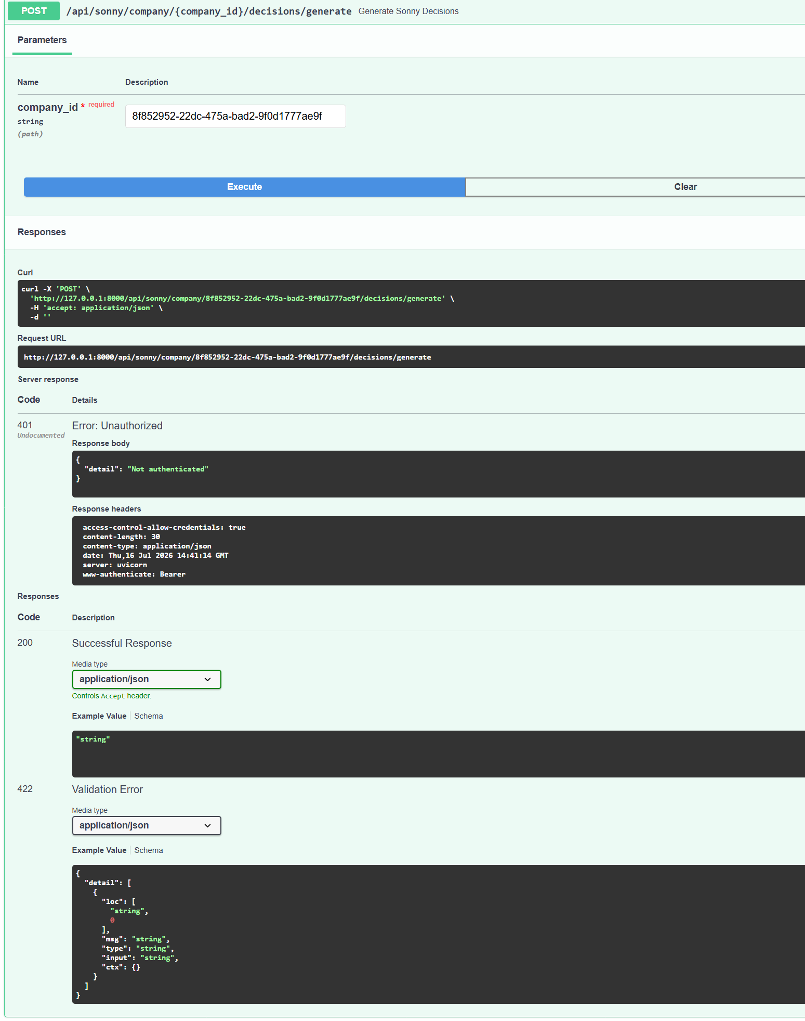

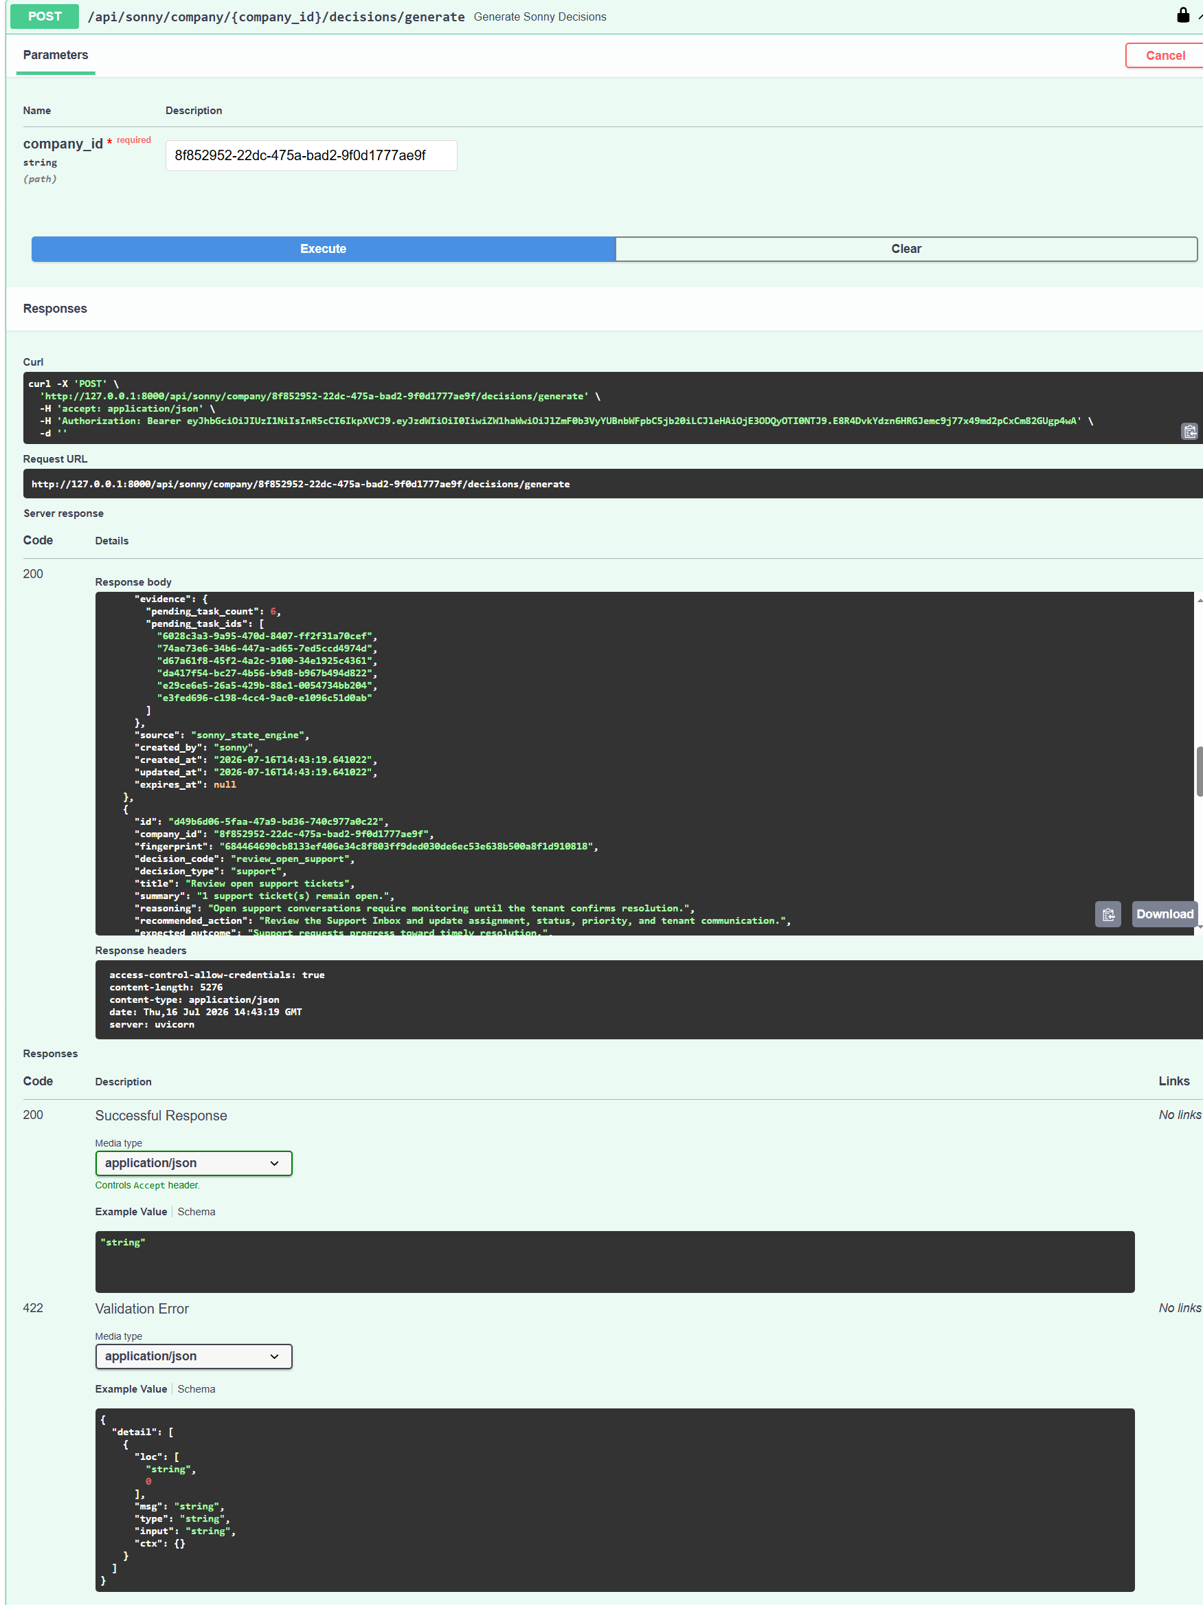
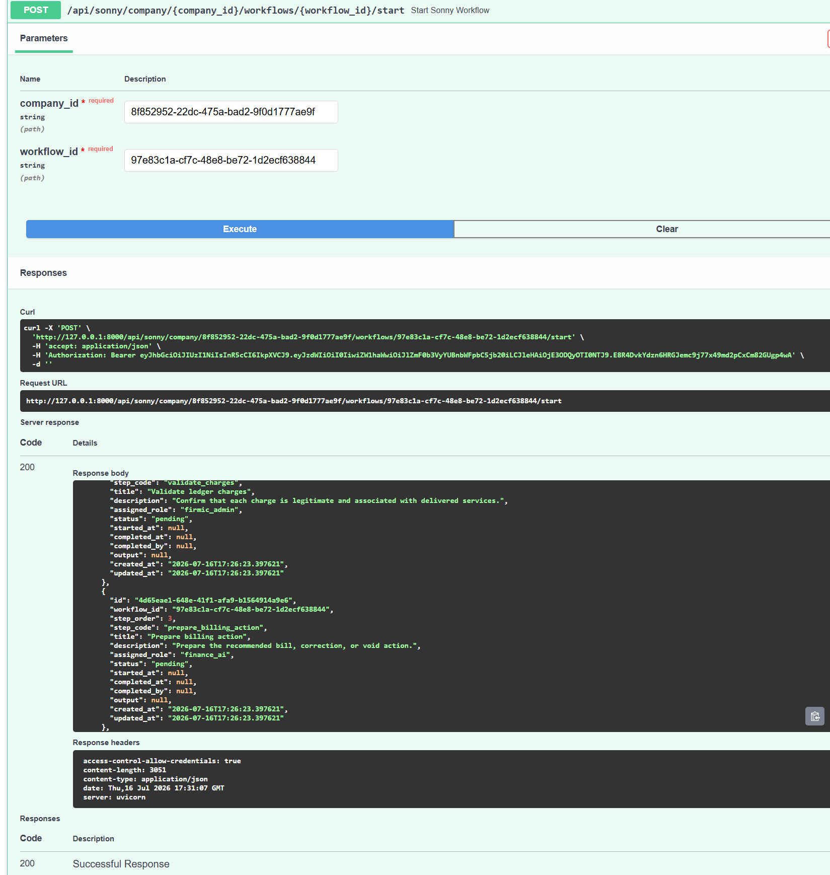

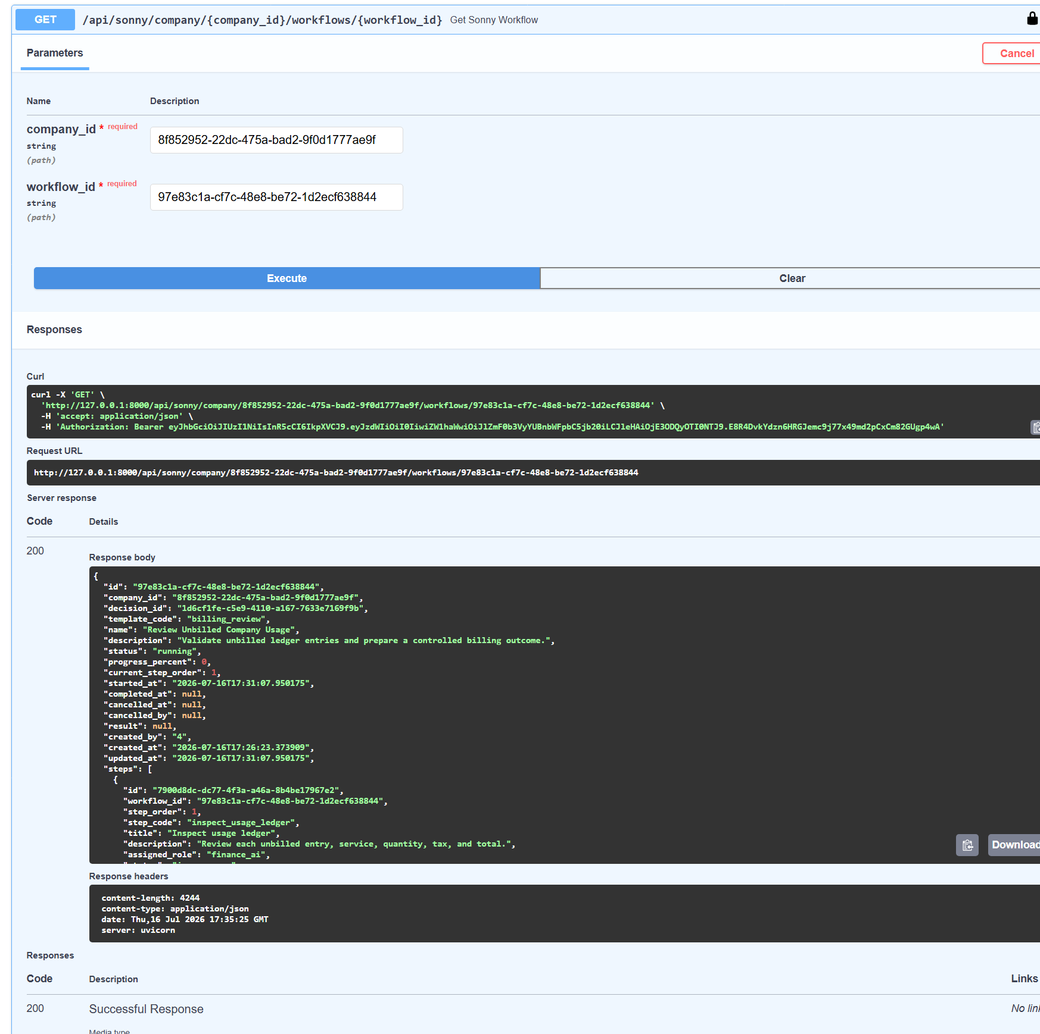

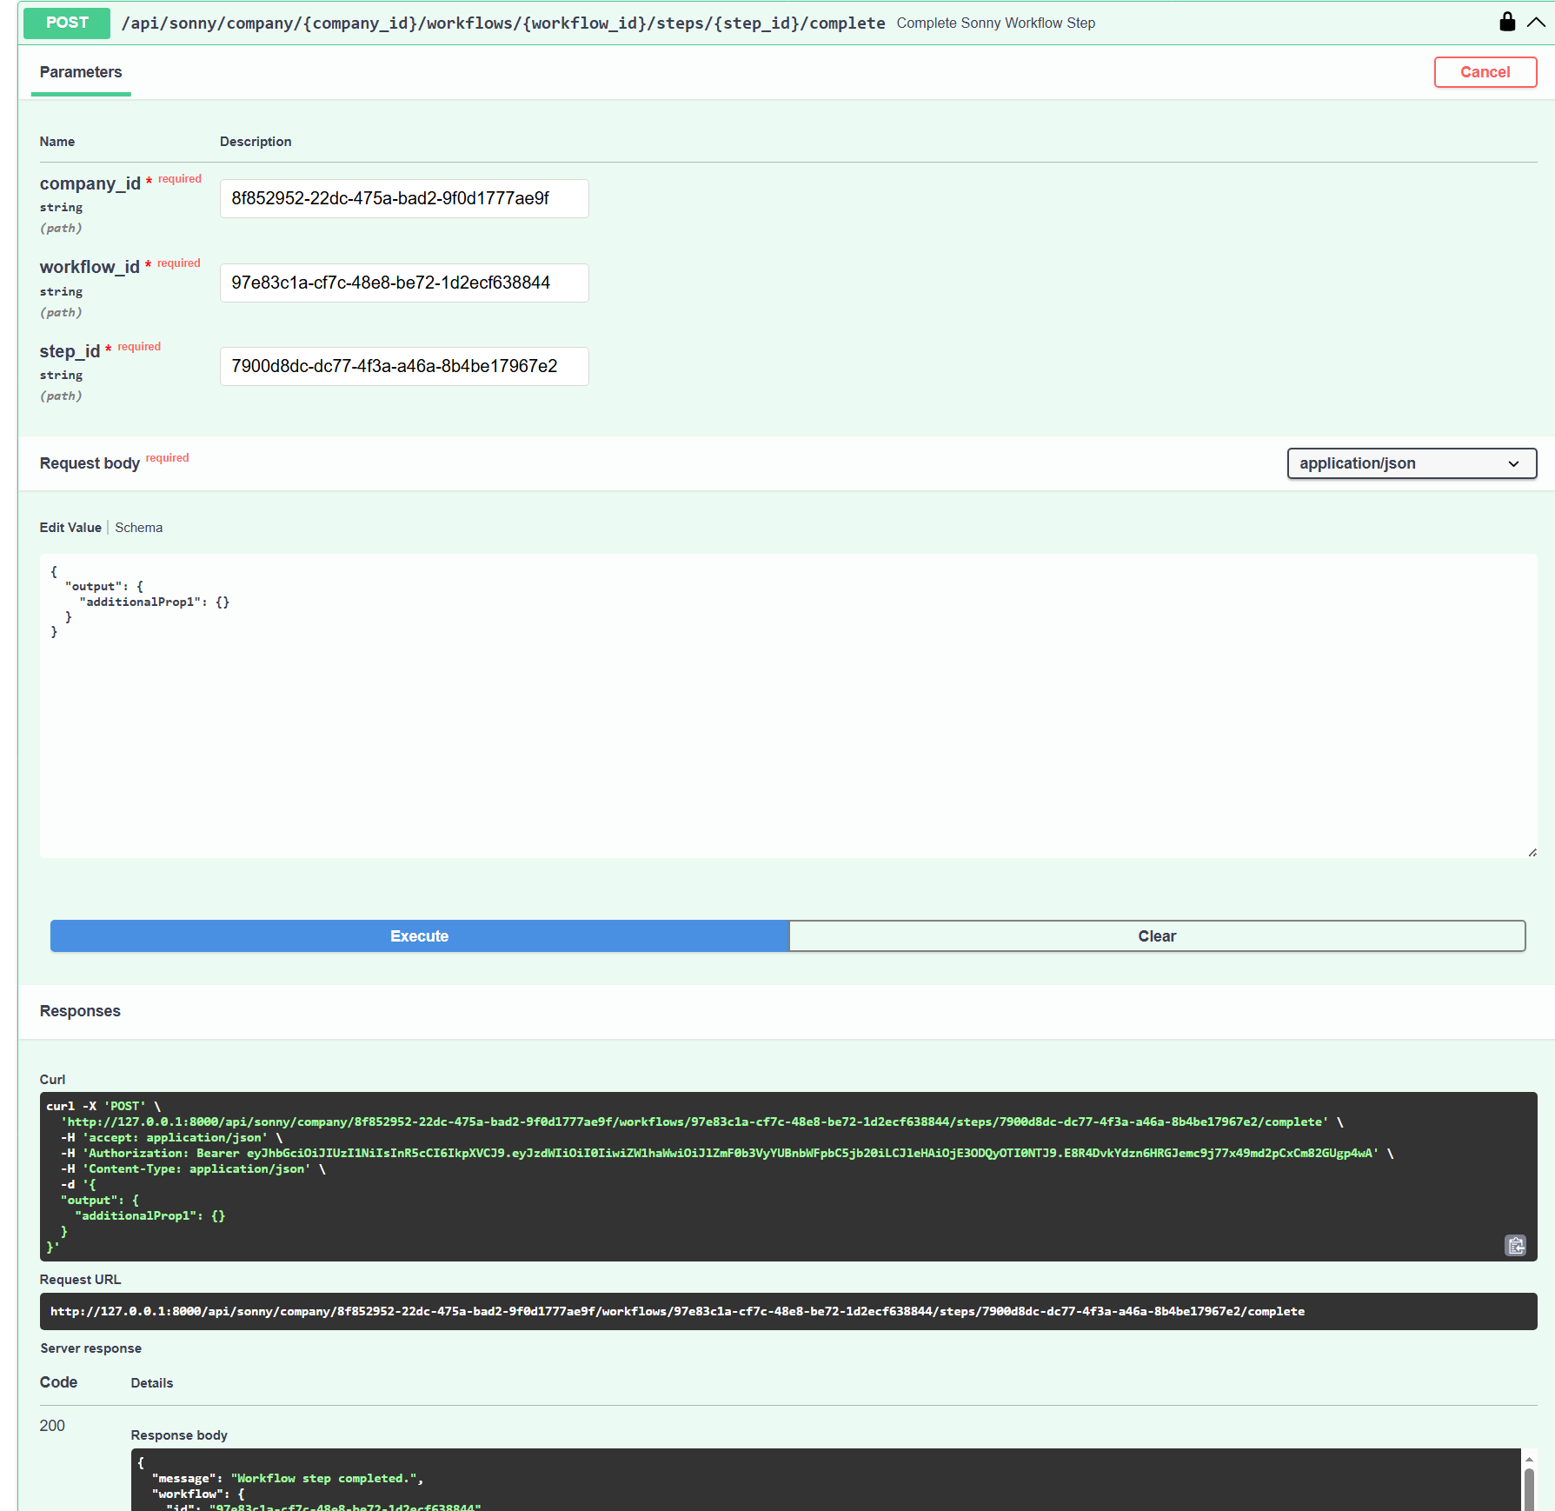

After B.2
Once the planner exists, the roadmap becomes very exciting:

B.3 — Memory Intelligence
Instead of just storing memories, Sonny begins learning patterns.
Examples:
- "Every month this company delays billing."
- "Support volume spikes after onboarding."
- "This founder always approves AI hires under $99/month."
- "Compliance documents are typically uploaded within two days."
Now Sonny has organizational memory, not just a database.

B.4 — Automation Engine
This is where approved workflows actually perform controlled actions.
Examples:
- Reserve an office
- Generate invoices
- Assign AI employees
- Open Hermes workflows
- Notify founders
- Schedule meetings
- Update CRM
Every action still follows the approval and safety rules you've designed.

B.5 — Multi-Agent Orchestration
At this stage, Sonny becomes the executive coordinator.
Instead of doing everything itself, it delegates:
Sonny
│
├── Hermes
│ Compliance
│ Documents
│
├── Julia
│ Marketing
│ Sales
│
├── Finance AI
│ Billing
│ Revenue
│
├── Receptionist AI
│ Calls
│ Visitors
│
├── Meeting Coordinator
│
└── Mailroom AI
Sonny becomes the conductor, while specialized AI employees execute their respective domains.

The end state
The vision we've been building toward is something like this:
Founder
│
▼
Sonny
│
┌────┼────┐
▼ ▼ ▼
Planner Decisions Memory
│
▼
Workflows
│
▼
Automation
│
▼
AI Workforce
│
▼
Firmic Platform
That's an AI-native operating system rather than a dashboard with AI features.

One thing I appreciate about your architecture
You've consistently kept a clear separation between thinking and acting:
- State Engine observes.
- Decision Engine recommends.
- Founder/Admin approves when required.
- Workflow Engine structures execution.
- Automation Engine performs controlled actions.
That separation will make Firmic easier to maintain, safer to extend, and much easier to trust as the platform grows.
I think B.2 is the right next milestone. Once it's complete, you'll have an AI COO that doesn't just answer questions—it starts every day with a plan, prioritizes work, tracks progress, and keeps the company moving forward. From there, the remaining phases are about expanding capabilities rather than inventing the core architecture.

Tonight: Finish Sonny

✅ B.2 — Planner
This is the executive brain.
Deliverables:
- Daily Executive Plan
- Weekly Plan
- Operational Priorities
- Blockers
- Pending Founder Approvals
- Overdue Workflows
- AI Workforce Recommendations
- Executive Brief
- Planner API
- Planner database

B.3 — Memory Intelligence
Right now Sonny stores memories.
After B.3 Sonny should understand memories.
Example:
Instead of
37 support tickets
Sonny knows
Support volume increased 42% after onboarding.
Instead of
18 invoices
Sonny knows
Billing is usually delayed five days by this founder.
This becomes institutional knowledge.

B.4 — Automation Engine
After approval...
Sonny executes.
Examples:
- create office
- assign AI employee
- notify founder
- create invoice
- launch workflow
- archive documents
- schedule meetings
Safely.
Controlled.
Auditable.

B.5 — Multi-Agent Orchestration
Then Sonny becomes CEO.
Instead of doing everything himself...
Founder
│
▼
Sonny
├─────────────┐
▼ ▼
Hermes Julia
Compliance Growth
│ │
▼ ▼
Finance AI Receptionist
│ │
▼ ▼
Mailroom Meeting AI
Sonny delegates.
Agents execute.

B.6 — Voice
This will completely change Firmic.
Imagine logging in and hearing:
"Good morning Hussein."
"Two companies require approval."
"Three invoices remain unpaid."
"Compliance is complete."
"I recommend activating Receptionist AI."
That's no longer software.
That's a COO.

Tomorrow
If we finish Sonny tonight...
Tomorrow becomes almost entirely product work instead of engineering.

Morning

1. Deploy
firmic.io
Backend
Frontend
PostgreSQL
SSL
Production

2. Final UI polish
Only cosmetics.
No architecture.

3. Pitch Deck
We already have most of the content.
Now we simply update screenshots with the finished platform.

4. Demo Video
This is where Hub71 investors will understand it.
A possible flow:
Login

↓

Create Company

↓

Sonny analyzes company

↓

Generates decisions

↓

Founder approves

↓

Workflow starts

↓

Hermes verifies documents

↓

AI Workforce activates

↓

Company is operational
That's a compelling demonstration because it shows an end-to-end operating system rather than isolated features.

5. Hub71 Application
This is where I think we'll have a real advantage.
Most applicants describe an idea.
You'll be able to show:
- A working platform
- Admin Console
- Tenant Workspace
- AI Workforce
- Hermes
- Sonny
- PostgreSQL backend
- Live APIs
- Workflow engine
- Decision engine
- Compliance engine
- Billing engine
That is a very different position from a typical MVP

Then...

B.3
Memory Intelligence
Sonny starts learning.

B.4
Automation Engine
Sonny starts acting.

B.5
Agent Orchestration
Hermes
Julia
Finance AI
Receptionist
Meeting AI
Mailroom
Everything coordinated by Sonny.

B.6
Voice COO
The day begins with:
Good morning Hussein.
Company readiness is 92%.
One founder approval is waiting.
Billing should be reviewed before 10 AM.
Compliance has no blockers.
That will be a genuinely compelling demo.

So here's what I propose for the rest of tonight:
- B.2.3 Planner API → I will generate a clean, complete replacement of your current routes/sonny.py with only the three planner endpoints added.
- B.2.4 Sonny Dashboard API → immediately after.
- B.3 Memory Intelligence
- B.4 Automation Engine
- B.5 Multi-Agent Orchestration
- B.6 Voice

Proposed B.7 roadmap
- ✅ B.7.1 Company Knowledge
- B.7.2 Executive Memory
- B.7.3 Conversation History
- B.7.4 Company Snapshot Engine
- B.7.5 Prompt Builder
- B.7.6 Voice + Speech
- B.7.7 Natural Language Command Interpreter
- B.7.8 Executive Confirmation Engine

Phase 1 — Finish B.7 (100% MVP)
This is our only engineering focus until it's complete.
- ✅ Company Knowledge
- ✅ Executive Memory
- ✅ Conversation History
- ✅ Executive Voice
- ✅ Company Snapshot Engine
- ✅ Prompt Builder
- ✅ Natural Language Commands
- ✅ Confirmation Engine
- ✅ Fix microphone UI
- ✅ Executive Dashboard ("Good morning..." briefing)
When this is done, Sonny should genuinely feel like the AI COO of the company.

Phase 2 — Production Readiness
Before deployment we'll do a complete production pass.

Security
- Remove debug endpoints
- Secure secrets
- Environment variables
- HTTPS
- Rate limiting
- Production logging
- Error handling

Performance
- Optimize API calls
- Lazy loading
- Caching
- Loading states
- Mobile responsiveness

Polish
- Consistent UI
- Animations
- Empty states
- Notifications
- Better icons
- Final branding

Phase 3 — Documentation
I don't just want documentation.
I want an onboarding experience.

Interactive Walkthrough
First login:
Welcome to Firmic.
Let me show you your company in under 5 minutes.
Then it guides the user through:
- Dashboard
- Head Office
- AI Workforce
- Sonny
- Mailroom
- CRM
- Meeting Center
- Billing

User Manual
A professionally designed PDF with screenshots.
Sections:
- Getting Started
- Creating a Company
- Renting Offices
- Managing AI Employees
- Digital Mailroom
- Communications
- Sonny AI COO
- Billing
- Reports
- Integrations
- FAQ

Video Tutorial
I think this is even more important than the manual.
A polished 8–12 minute product walkthrough:
- What is Firmic?
- Create your company
- Rent an office
- Hire AI employees
- Use Sonny
- Create orchestrations
- Billing
- Reports
- Future roadmap
We can script this together so it feels like a launch presentation rather than a screen recording.

Phase 4 — Deployment
Deploy:
- Frontend
- Backend
- PostgreSQL
- Domain
- SSL
- Email
- Storage
- Monitoring
Then we test everything in production.

Phase 5 — Hub71 Package
This should be a complete investment package, not just an application.
It should include:
- Executive Summary
- Pitch Deck
- Product Demo
- Product Video
- User Manual
- Technical Architecture
- Business Model
- Financial Projections
- Roadmap
- Competitive Analysis
- Team
- Hub71 Application
Everything should tell one consistent story.

Phase 6 — Investor Version
After Hub71, we prepare for investors.
That version will include:
- live demo
- traction metrics
- customer onboarding
- testimonials (when available)
- investment memo
- data room

One recommendation
I also suggest we add one last page before deployment:

Sonny Intelligence Center
This isn't just a settings page. It's where founders configure Sonny's brain.
It would include tabs for:
- Knowledge – Company profile, services, SOPs, pricing, FAQs.
- Memory – Executive memories and long-term preferences.
- Voice – Choose Browser, OpenAI, or ElevenLabs voice and adjust speaking style.
- Behavior – Executive tone, approval rules, communication style.
- Permissions – What Sonny can read and what requires approval.
- Conversation Logs – Searchable history of discussions and actions.
This gives users confidence that Sonny is configurable and transparent, and it neatly ties together everything we're building in B.7.
From a product perspective, I think we're now building something much bigger than a virtual office. We're building an AI operating system for companies, with Sonny as the executive interface that makes the entire platform feel unified. That's exactly the experience we should aim to showcase when we deploy and present Firmic.

